**2 STAGE OTA**

**Circuit diagram:**

**Closed loop gain:**

Gain = 2

= 20 log (2) = ~6dB

Band width ~10MHz

**Open loop gain:**

**Stage-1:**

Gain = 192.25  
 = 45.677dB(lt spice amplitude)

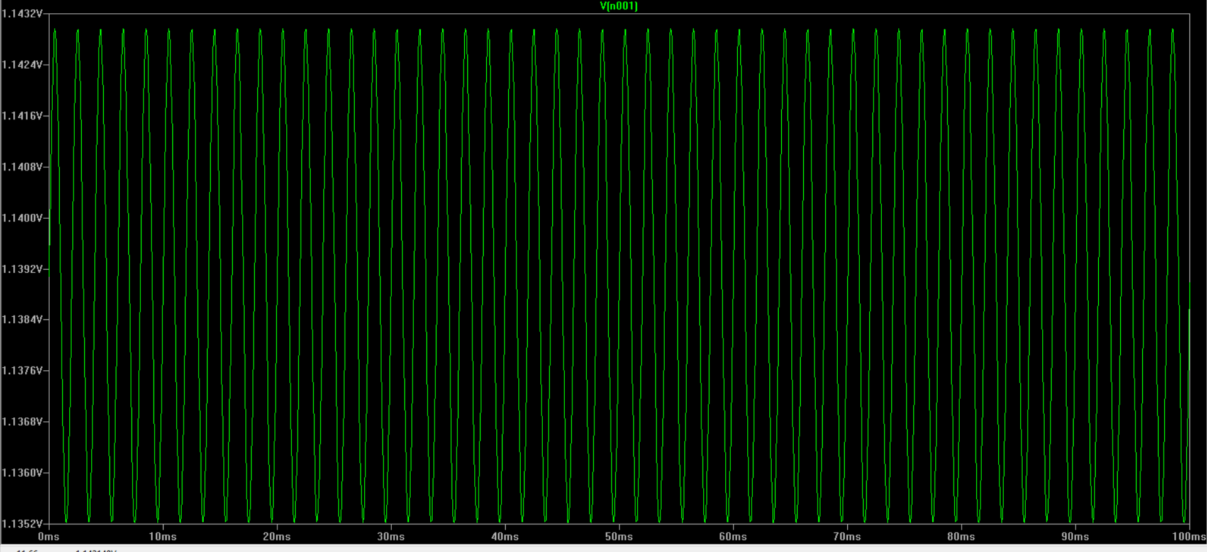

**Overall gain:**

Gain = 1107.25(from amplitude)  
 = 60.885dB

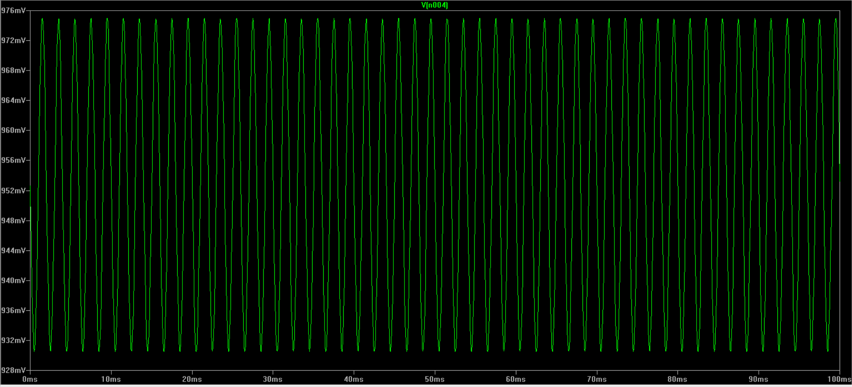

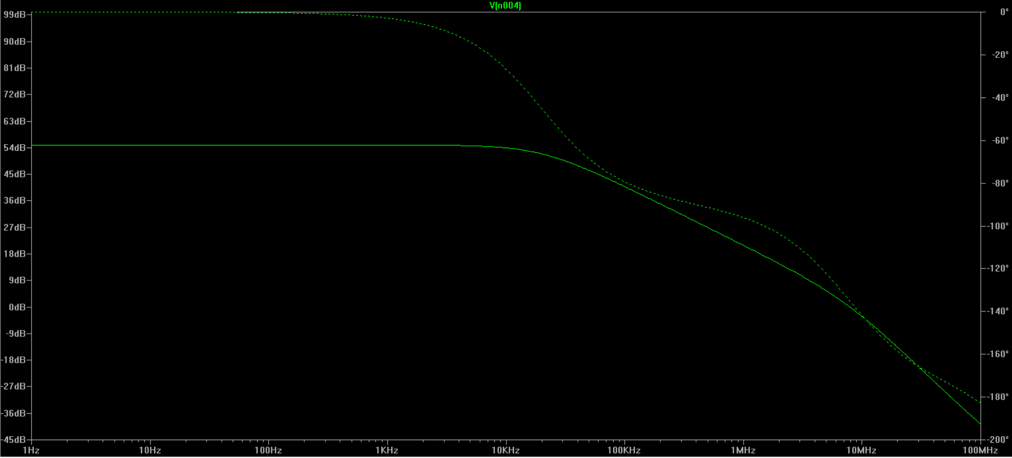

Phase margin(from plot): 180-116.7 = 63.3 degrees  
Band width = ~20kHz

**Step response:**

**I added C = 0.22CL  
where CI took as 2pF so CL  = 9.09Pf**

**For the phase margin to be around 60 degrees I took the value of resistor as 300ohms**

**I have placed negative feedback loop with resistors 10k and 10k as shown in circuit to get non inverting gain as 2 = ~6dB .**